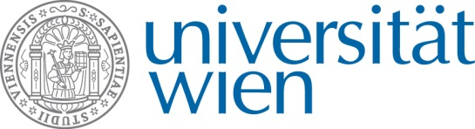
Ao. Univ. Prof. Dr. Johannes Saukel
Dep. of Pharmacognosy
University of Vienna
Althanstrasse 14
A-1090 Vienna

An Frau DDr. Hedda Sützl-Klein
European Society for Integrative Health Research (ESIHR)
Zieglergasse 27/3/18
A-1070 Vienna

Vienna, 18.1.2012

Re: Letter of Intent - Project: Alpine Medicine

Dear DDr. Sützl-Klein,

Thanks for your invitation. I am happy to join your project – Alpine Medicine – as a project partner.
I can offer two work packages:
- Compilation of printed information on traditional medicine to enhance our so called “VOLKSMED”- data base
- Scientific assessment of important parts of the new established data base – Alpine Medicine. All medically sensible plants or preparations are listed as recommendations for expert groups of the Pharmacopoeias of partner countries. The final step should be the formal integration of this plants or preparations in the Pharmacopoeias.

If you need any further information please do not hesitate to contact me.

Yours sincerely

Johannes Saukel

